Delta Omicron Lambda
3.7
3.6
3.5
3.4All Female
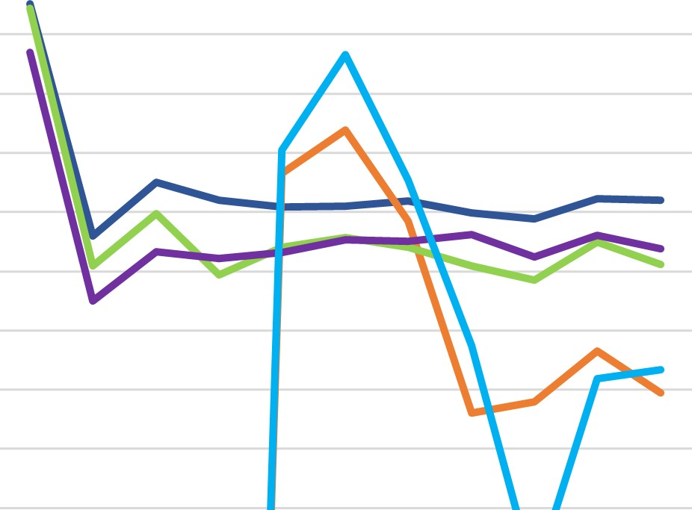
3.3......—AII GIC
3.2All Greek
All Student 3.1
............—Delta Omicron Lambda
3
2.9
2.8
S20 F20 S21 F21 S22 F22 S23 F23 S24 F24 S25

